Short Communication

Canine lymphomas: DNA changes in tumour genes

Monika Drážovská∗, Katarína Šiviková, Gabriel Bóna
Department of Genetics, University of Veterinary Medicine and Pharmacy in Košice
Article Details: Received: YYYY-MM-DD | Accepted: YYYY-MM-DD | Available online: YYYY-MM-DD
dx.doi.org/10.14514/xxxxxxxx

Lymphoma is the most frequent hematopoietic neoplasm in dog, and it shares some clinical, cytological, histopathological and molecular similarities with humans. In our study, DNA changes in TP53, c-KIT and N-RAS were detected in lymphoma tissues of cross breed bitch and Bernese Mountain Dog bitch. One transition A/G at nucleotide position 138 in exon 5 in TP53 gene and one transition G/A at nucleotide position 35 in exon 8 of c-KIT gene were observed in donor 2. It seems that these genes did not play a key role in canine lymphoma formation and progression.
Keywords: canine lymphoma, TP53, C-KIT, N-RAS

Introduction
Lymphoma represents a heterogeneous group of neoplastic blood disorders involving monoclonal proliferation of malignant lymphocytes. Historically, lymphomas have been divided in two basic categories: Hodgkin lymphoma (HL) and Non-Hodgkin lymphoma (NHL) (DeVita et al., 2015). Different subtypes were described in current WHO classification (WHO, 2008), which is based on various biological and clinical features of the disease. In humans, 5.1 % of all cancer cases was diagnosed as NHL and 2.7 % of all cancers had been a cause of death. (Boffetta, 2011).
Numerous chromosomal imbalances have been documented in human lymphomas (Hallermann et al., 2004). For example, translocation t(14;18) have been recorded by D´Haese et al. (2005) after sequencing of the BCL2 gene in patients with follicular non-Hodgkin´s lymphoma. Mutations in a lymphoid tissue have also been observed in mice. DNA changes in five genes (Bcl11b, Ikaros, Myc, Pten and Notch1) have been documented by Ohi et al. (2007) in mice with thymic lymphomas after γ-irradiation In this paper the potential DNA changes in two protooncogenes (N-RAS and c-KIT), and TP53 tumour suppressor gene were analyzed in canine lymphomas.

Material and methods

Isolation of test and reference DNA
The tested genomic DNA was isolated from the tumour tissues (lymphomas) from two 10- and 12-years old bitches. One dog (donor 1) was a cross breed bitch (with a solid tumour in a node) and the second (donor 2) was Bernese Mountain Dog bitch (in a final stage of cancer with numerous metastases). The DNA reference was isolated from the whole blood of healthy dog (Jack Russell Terrier dog, 7 years old), using the DNeasy® Blood & Tissue Kit (Qiagen, Venlo, Netherlands).

Design of primers and PCR reaction
Specific primers were designed for Canis lupus familiaris genes as follows: for TP53 gene, exons 5, 6 (ENSCAFE00000181392, 187bp and ENSCAFE00000181396, 113bp; including intron), and exons 7, 8 (ENSCAFE00000181397, 110bp and ENSCAFE00000181399, 137bp; including intron), for c-KIT, exon 8 (ENSCAFE00000022604, 115bp) and exon 17 (ENSCAFE00000022614, 123bp) and for N-RAS, exon 1 (ENSCAFE00000103409, 128bp) and exon 2 (ENSCAFE00000103411, 179bp) by Primer3Plus software. PCR reaction mixture consisted of 10 µl PCR Master Mix (Promega M 750, Fitchburg, WI, USA); 0,4 µl primers; 0,5 µl tested DNA and 9,1 µl PCR Ultra H2O (Top Bio, Prague, Czech Republic) with the total volume of 20 µl. The standard PCR programme included five steps. Initial DNA denaturation phase starting at 95ºC for 5 min was followed by subsequent repetition of 30-35 cycles: 30 s at 95ºC for DNA denaturation, 45 s at variable temperatures (54-61ºC) for primer annealing, 45 s at 72ºC for amplification. Final extension step was set for 45 s at 72ºC and followed by rapid cooling to 4ºC. The products of PCR reaction were analysed by agarose gel electrophoresis (1,5%) with GelRed (Biotinum, Hayward, CA, USA) staining and visualization under UV illumination - GenoView Smart M (VWR GenoView, Radnor, PA, USA).

DNA sequencing
The PCR amplicons of all gene exons were sequenced by ABI PRISM 3100-Avant Genetic Analyzer (Applied Bio-systems, Waltham, MA, USA) (Laboratory of Biomedical Microbiology and Immunology, UVLF in Košice). The results of sequencing were compared with the reference sequences in GenBank and for TP53 evaluated by the DNASTAR program under the accession number NM_001003210, and for c-KIT and N-RAS in NCBI under the accession numbers AY313776.1 and NM_001287065.1.

Results and discussion
Cancer is the result of several genetic events in somatic cells, and in some cases the result of predisposition to inhered mutations in the responsible genes. Studied genes TP53, c-KIT and N-RAS were chosen based on our previous results of the CGH analysis, by which a number of imbalances on the canine chromosomes (both cross breed bitch and Bernese Mountain Dog) were detected (Drážovská et al., 2016).
Nucleotide sequences of ten amplicons (shown in Fig. 1) were compared with reference sequences. A total, only two nucleotide substitutions (transitions) were identified in donor 2; One A/G at nucleotide position 138 in exon 5 in TP53 gene (Fig. 2), and the second one, G/A at nucleotide position 35 in exon 8 of c-KIT gene (Fig.3).
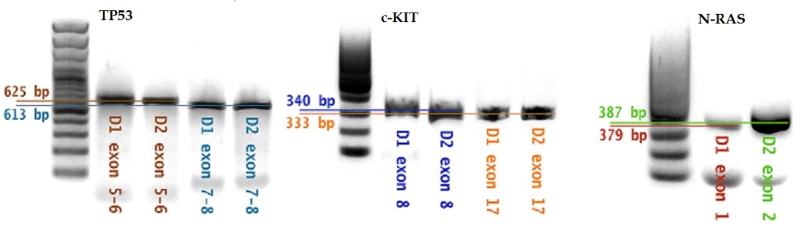

Figure 1 Electrophoresis of PCR amplicons of genes TP53, C-KIT and N-RAS (DNA ladder-100bp); D1 - donor 1; D2 - donor 2

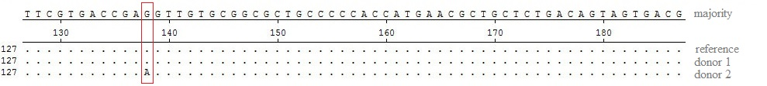
Figure 2 Sequencing of exon 5 TP53. Transition A/G at position 138 in Bernese Mountain Dog bitch (donor 2)

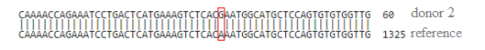

Figure 3 Sequencing of exon 8 c-KIT. Transition G/A at position 35 in Bernese Mountain Dog bitch (donor 2)

The TP53 is a key of the tumour suppressor genes controlling cell cycle proliferation, mutations in which are most frequently described in association with numerous cancer diseases. Single base-pair missense mutations in TP53 gene have been most frequently identified in humans. Brathwaite et al. (Brathwaite et al., 1992) described several mutations in exons 5, 7 and 8 in murine thymic lymphomas; G:C to A:T transitions were also occurred more frequently. In contrast to these findings, no point mutations in exons 5-8 of the p53 gene were recorded by Hollstein et al. (1997) in 13 iatrogenic human liver cancers or in canine brain tumours (York et al., 2011), as well.
The proto-oncogene c-KIT plays an important role in proliferation, survival and differentiation of hematopoietic progenitor cells. In humans, c-kit expression has been well documented in different hematopoietic neoplasms, like acute myeloid leukemia, granulocytic sarcoma, systemic mastocytosis, T-cell acute lymphoblastic leukemia and multiple myeloma; contradictory results have been reported in lymphomas.
The RAS genes (N, K and H) encode proteins important in cell signal transduction. Although missense mutations in N-RAS gene were detected by Usher et al. (2009) in 25% dogs with acute lymphoid leukaemia, our results indicated that N-RAS gene activation in canine lymphoma is rarely, like as considered Mayr et al. (2002).

Conclusions
Canine lymphoma (cL) represents the most common hematopoietic neoplasia in dog and involves many similarities in clinical expression, molecular mechanisms, treatment and drug response with human NHL (15). Only two nucleotide substitutions (transitions) were found in TP53 and c-KIT genes in donor 2. Position of genes on canine chromosomes is not known. We assume that studied genes were either not located in the place of detected chromosome imbalances (Drážovská et al., 2016) or chromosomal rearrangements did not lead to the changes in their activity. Probably these genes did not play a key role in canine lymphoma formation and progression.

Acknowledgments
This work was supported by the Ministry of Education, Science, Research and Sport of the Slovak Republic throught contract Vega No. 1/0043/15 and No. 1/0176/16.

References
BOFFETTA, P.I. (2011) Epidemiology of adult non-Hodgkin lymphoma. Ann Oncol, vol. 22, pp. 27-31. doi: http://dx.doi.org/10.1093/annonc/mdr167.
BRATHWAITE, O., et al. (1992) p53mutations in C57BL/6J murine thymic lymphomas induced by ᵞ-irradiation and N-methylnitrosourea. Cancer Res, vol. 52, pp. 3791-3795.
DEVITA V. et al. (2015) Cancer: Principles & Practice of Oncology. Primer of the Molecular Biology of Cancer. s.l. : Wolters Kluwer. 978-1496310637.
D´HAESE, J.G., et al. (2005) Chromosomal aberrations in follicular non-Hodgkin lymphomas of Japanese patients, detected with comparative genomic hybridization and polymerase chain reaction analysis. Cancer Genet Cytogenet, vol. 162, pp. 107-114. doi: //dx.doi.org/10.1016/j.cancergencyto.2005.04.004.
DRÁŽOVSKÁ, M., et al. (2016) Comparative genomic hybridization in detection of DNA changes in canine lymphomas. Anim Sci J. doi: //dx.doi.org/10.1111/asj.12582.
HALLERMANN, C., et al. (2004) Chromosomal aberration patterns differ in subtypes of primary cutaneous B cell lymphomas. J Invest Dermatol, vol. 253, pp. 49-53. doi:10.1111/j.0022-202X.2003.12635.x.
HOLLSTEIN, M., et al. (1997) p53 gene mutation analysis in tumours of patients exposed to alpha-particles. Carcinogenesis, vol. 18, pp. 511-516. doi: 10.1093/carcin/18.3.511.
MAYR, B., et al. (2002) N-ras mutation in feline lymphoma. Low frequency of N-ras mutations in a series of feline, canine and bovine lymphomas. Vet J, vol. 163, pp. 326-328. doi:10.1053/tvjl.2001.0691.
OHI, H., et al. (2007) Multi-step lymphomagenesis deduced from DNA changes in thymic lymphomas and atrophicthymuses at various times after ᵞ-irradiation. Oncogene, vol. 26, pp. 5280-5289. doi:10.1038/sj.onc.1210325.
USHER, S.G., et al. (2009) RAS, FLT3, and C-KIT mutations in immunophenotyped canine leukemias. Experimental Hematology, vol. 37, pp. 65-77. doi:10.1016/j.exphem.2008.09.005.
WHO (2008) Classification of Tumours of Haematopoietic and Lymphoid Tissues. Swerdlow, S. H. et al. Lyon, France : IARC Press, vol. 117, pp. 5019-5030.
YORK, D., et al. (2012) TP53 mutations in canine brain tumours. Vet Pathol, vol. 49, pp. 796-801. doi: 10.1177/0300985811424734.

∗ Corresponding Author: Monika Drážovská. Department of Genetics, University of Veterinary medicine and pharmacy in Košice, Komenského 73, 041 81, Košice, Slovak Republic. E-mail: drazovska@gmail.com

